/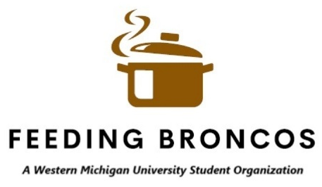

VOLUNTEER SIGN UP
EVENT: ---BRONCO BASH—
DATE: ---9/15/2025---
LOCATION: Kanley Chapel – Dialogue Room
Date | Time | Name (Print) | Email
9/15
9/18

